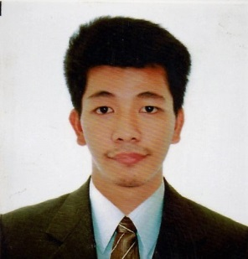

**MARK LESTER HEBREO MAGNO**

#88 Jenkins St. Poblacion District IV Pozorrubio, Pangasinan

Mobile Number: (0949) 605 0071

marklesterhebreomagno25@gmail.com

**Objective**: A challenging, rewarding position utilizing my skills and capabilities.

**EDUCATIONAL BACKGROUND**

**College Degree**

* **Pangasinan State University (Urdaneta City Campus)**

Bachelor of Science in **Computer Engineering**

*June 2010 – May 2017*

**Vocational**

* **College of St. Michael the Archangel (Binalonan Campus)**

PC Operation

*2007-2008*

**Secondary Level**

* **Benigno V. Aldana National High School**

Pozorrubio, Pangasinan

*2002-2006*

**Trainings and Seminar Attended:**

* **Android Mobile Applications Linked with Embedded Systems**

University of Pangasinan – PHINMA

*March 14, 2016*

**On-the-Job Training**

* **National Bureau of Investigation (NBI-CAR)**

125 Upper Session Road, Baguio City

*June 13, 2016 - July 22, 2016*

**Other Skills:**

Knowledgeable in **Microsoft Office**

Knowledgeable in **Auto CAD** design

Knowledgeable in **Arduino Programming**

* Line follower Mobot
* Collision detection Mobot
* Table Top/Anti-fall Mobot
* Sumobot
* Quadcopter

Knowledgeable in **Pneumatics** and **Electro-pneumatics**

Basic knowledge in **Raspberry Pi**

Basic knowledge in programming languages such as **HTML**, **CSS**, **MySQL**

Basic knowledge in **PLC programming**

Basic knowledge **GNS3**, **Servers** and **subnetting**

Basic knowledge in Adobe Photoshop and canva

Website Portfolio: https://marklesterhmagno.github.io/index.html

**REFERENCES:**

**Engr. Roderick L. Calaguio**

PSU Urdaneta Instructor

Urdaneta City, Pangasinan

(0933) 110 1295

**Engr. Kenneth Oliver S. Lopez**

PSU Urdaneta Instructor

Urdaneta City, Pangasinan

**Erwil Bernie V. Marzan**

Master electrician

National Grid Corporation of the Philippines

(0906) 232 2808

*All above information are certified true and correct to the best of my knowledge.*

**MARK LESTER H. MAGNO**